**User story for sprint 3**

**List Members:**

**Hoàng Bảo Vy**

**Tống Thị Trâm**

**Nguyễn Minh Châu**

**Phạm Huy Hoàng**

**Nguyễn Đức Thắng**

1. **Manage Cart**

* Card

As a user, I want to manage my cart, so that I can add a new product into my cart, delete it if it is no longer in use or update the quantity if it is necessary.

* Conversation
* Cart information: Image, description, price, quantity, total prices.
* Add new products into the cart manually.
* Display information about product that have already add into the cart in table
* Product information will be entered on the “Add to cart” field.
* Button “Add”.
* After clicking Add to Add product into the cart, the product will appear in the user's cart.
* Confirmation
* Add, edit and delete products in my cart manually.
* Product will be added to cart with valid data: name. image, price, quantity, total prices.
* Display an error when:

Edit Product quantity in cart

If the user enters the number of quantities that is less than 1 or blank, the prompt “Quantity is an integer greater than >= 1”.

* Scenarios

1. Add Product into the cart:

* Open website
* Choose the product that want to add into the cart
* Click the button cart that is located on the right of the screen, beside that user icon.
* In this system, the user can manage the cart

2.Edit quantity of Product :

* Select a Product
* Choose a quantity box, in this box, the user can enter or change the quantity that they want by clicking the box quantity and entering the number of quantities.
* Confirm product information update (e.g by clicking “Update information”)
* System confirms a confirmation message

3.Delete Product:

* Click Delete red button that located in left of screen
* System asks Admin to confirm deletion: “Are you sure you want to remove this product from your shopping cart?”
* Click Yes
* System displays a message confirming the successful deletion.

Mockup for Manage Cart

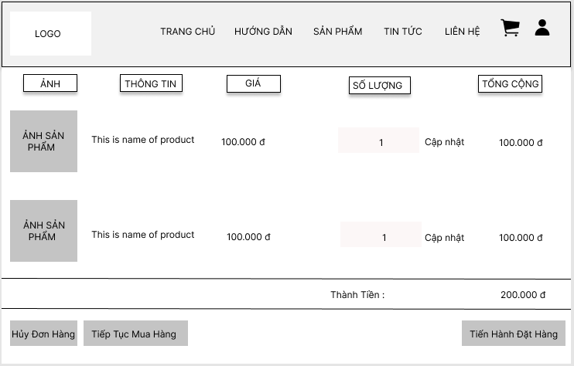

**2. Manage Contact:**

* Card

As an administrator, I want to manage contact, so that I can view the user's contact , delete it if it is no longer in use.

* Conversation
* Admin: They want to view, delete  contact with id, name, phone number, email, description. date created so they can manage your contact.
* They must enter in the required field valid email and name that can not be empty.

+   email: correct email format

* Button: “Act”
* After successfully, the admin can see all information about the user.
* Confirmation
* View, delete user manually success.. show…
* Display all users' details in one table, sorted by name, email address, date created and description.
* Display an error when:

1. View contact:

None.

2. Delete contact

None

* Scenarios

1. View Contact

* Admin access to the admin page.
* Click on box Manage Contact in the table
* Choose the contact that you want to see

2. Delete User:

* Admin access to the admin page.
* Click on box Manage Contact in the table
* Choose the contact that you want
* Click Delete button in one user’s table row
* System asks Admin to confirm deletion
* Click Yes
* System displays a message confirming the successful deletion.

Mockup for Manage contact

